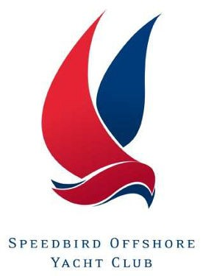
SOYC Request for Club Coastal Skipper status

APPLICANT DETAILS
Name
E-Mail address
I have read and understood the sailing orders relating to this qualification
Signature

Qualifications |  | Certificate details
 |  | Date | Number
SOYC Day Skipper appointment
SOYC Improve Your Skills Course
RYA First Aid
RYA Shore-based Coastal Skipper Theory Course
RYA/MCA Yachtmaster Coastal Certificate
Maritime Radio Operator Certificate of Competence - Short Range Certificate
SOYC Practical Radar OR RYA Radar Certificate if yacht skippered Radar equipped
Logged Sea time  To be confirmed by SOYC Director of Sailing | Total Days | Club Days | Night hours

Approved by
Signed:

Please complete this form , add scanned copies of any certificates not already noted on your Club Record. Send it to the Director of Sailing, sailing@soyc.co.uk and to training@soyc.co.uk

